**61.1. Spring REST - Exception Handling**

**Our problem when retrieve a single student**:

* Bad student id of 9999.

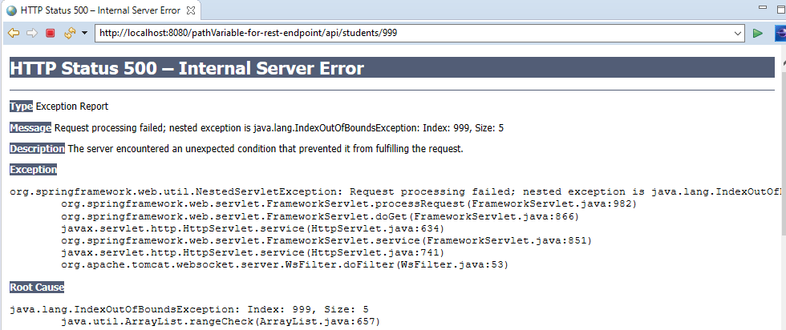

This is really a scary HTML error page. It has a lot of data that we really don't expose, such as the entire stack trace, and so on.

**We handle this exception**:

We want to handle this exception and return error as JSON.

{

"status": 404,

"message": "Student ID not found: 44",

"timeStamp": 1564376767213

}

**Spring REST Exception Handling**:

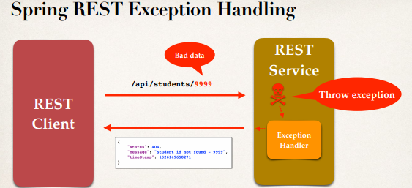

**Development Process (Step-by-Step)**:

1. Create a custom error response class
2. Create a custom exception class
3. Update REST service to throw exception if student not found
4. Add an exception handler method using **@ExceptionHandler**

**Step 1: Create custom error response class**:

* The custom error response class will be sent back to client as JSON
* We will define as Java class (POJO)
* Jackson will handle converting it to JSON

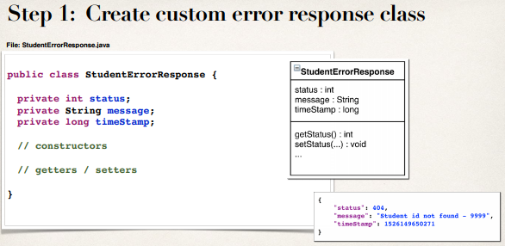

**Step 2: Create custom student exception**:

* The custom student exception will used by our REST service
* In our code, if we can't find student, then we'll throw an exception
* Need to define a custom student exception class
  + **StudentNotFoundException**

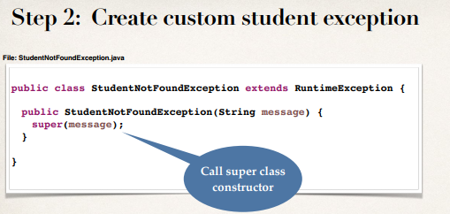

**Step 3: Update REST service to throw exception**:

* First check that the stunent_id is present or not in the database.
* If data present then display the student.

**The stunent_id is present or not in the database**:

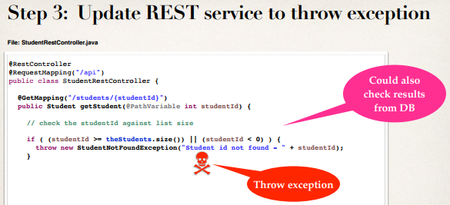

**If data present then display the student**:

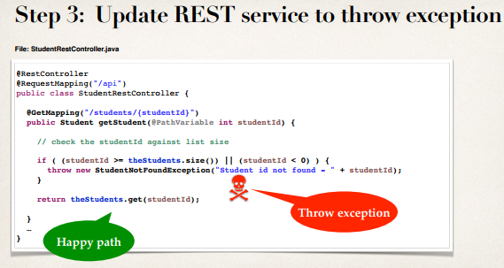

**Step 4: Add exception handler method**:

* Define exception handler method(s) with **@ExceptionHandler** annotation
* Exception handler will return a **ResponseEntity**
* **ResponseEntity** is a wrapper for the **HTTP** response object
* **ResponseEntity** provides fine-grained control to specify:
  + HTTP status code, HTTP headers and Response body

**Note**:

By using "**ResponseEntity**" we have a bit more control over how we send back the response to the calling program.

**Exception Handle Method Details**:

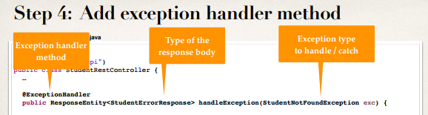

**Add exception handler method**:

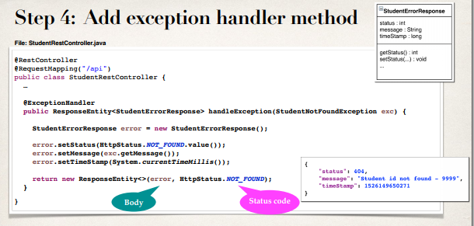

61.1. Spring REST - Exception Handling